Chapter 5c

**Steady State Errors**

**For a unity feedback control system**, the error is the difference between the input and the output.

G(s)

Y(s)

R(s)

B(s)

U(s)

Figure 5.17



The error signal is simply



**For a non-unity feedback system** the error is defined.

G(s)

Y(s)

R(s)

B(s)

E(s)

H(s)

Figure 5.18



**Type of Control Systems**

It has already been established that the steady state error depends on the input and the type of the system. In this section we will consider the type of the system.

Consider that a control system with unity feedback can be represented by or simplified to the following block diagram.

G(s)

Y(s)

R(s)

B(s)

U(s)

Figure 5.19

We have already established that



Clearly  depends on the characteristics of G(s). More specifically we can show that depends on the number of poles that G(s) Has at s=0. This number is known as the type of the control system or simply system type.

In general GH(s) can be expressed for convenience as



The system type refers to the order of the pole of G(s) at s=0. Thus the closed lop system having the forward path transfer function the above equation is type j where j= 0,1,2…

The total number of terms in the numerator and the denominator and the values of the coefficients are not important to the system type. As system type refers only to the number of poles G(s) had at s=0.

The type of the control system is the order of the poles of GH(s) at the origin i.e. j in the above expression. J is the number of pure integrators in the control loop

**Examples 5.1**



Steady state Error due to **step input**

When the input r(t), R(s) is a step input 





Now we have already said that



If there are no pure integrators in the control loop a step input will result in a finite steady state error. If there is at least one pure integrator in the loop the steady state error for a step input will be zero.

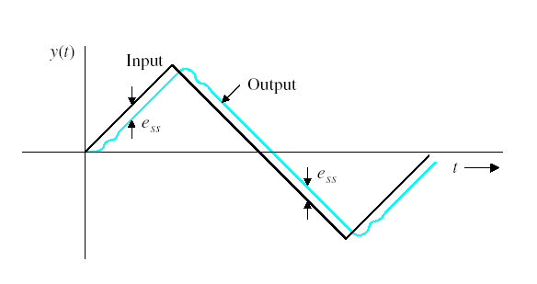

Figure 5.20

Steady State Error due to Ramp Input



If there are no pure integrators in the control loop a ramp input will result in an infinity error . One pure integrator (type 1 ) system will result in a finite error. 2 pure integrators in the loop the steady state error is zero

Ref input

Output

Typical Steady state Error Due to Ramp input

A(t) 

Figure 5.21

**Steady state error of a system with Parabolic input**



We need at least 3 pure integrators in order to avoid steady state error

|  |  |  |  |  |  |  |
| --- | --- | --- | --- | --- | --- | --- |
| Type No  j |  |  |  | Step | Ramp | Parabolic |
| 0 |  | 0 | 0 |  |  |  |
| 1 |  |  | 0 | 0 |  |  |
| 2 |  |  |  | 0 | 0 |  |
| 3 |  |  |  | 0 | 0 | 0 |
| 4 |  |  |  | 0 | 0 | 0 |

Table 5.1

Consider the following Transfer function



the first step in carrying out steady state error calculation is to check if the system is stable or not.



Now that the stability has been validated we can continue with our steady state analysis



**RAMP INPUT**



**PARABOLIC INPUT**



**Example 5.1**

Given that the open loop transfer function is



Using Routh Hurwitz criterion shows that the closed loop system is unstable for all values of K and thus error analysis is meaningless.

**Example 5.2**



It can be shown that the closed loop system is stable. The steady state error are

calculated for three basic types of inputs

|  |  |  |
| --- | --- | --- |
| Step input | Step-error constant |  |
| Ramp Input | Ramp-error constant |  |
| Parabolic input | Parabolic-error constant |  |

Table 5.2